**Hydrogen Line Doppler Mapping of Eight Nearby Galaxies Using the 20m Skynet Dish at Greenbank Observatory**

***Dr Andrew Thornett, M6THO, Lichfield Radio Observatory, Lichfield, UK*** [***www.astronomy.me.uk***](http://www.astronomy.me.uk)

***Jason Burnfield, Electronics Engineer III, Data Acquisition Group, National Radio Astronomy Observatory (NRAO), Domenici Science Operations Center (DSOC): Rm. 257***

***Article for SARA Journal***

**Greenbank 20m Skynet Radio Telescope.**

The 20 m telescope was built by RSI and delivered to Green Bank in 1994 as part of the US Naval Observatory's Earth Orientation (geodetic VLBI) program. It operated from 1995 until 2000, when USNO funding was cut, and the facility was repurposed for testing and education (Green Bank Observatory 20m, accessed 2025). In 2012, the dish was refurbished and integrated into the Skynet Robotic Telescope Network, becoming the first radio element of the UNC Chapel Hill operated network. The dish has 20m diameter, with F/D ratio: 0.43. The receivers are cryogenically cooled (≈15 K) HEMT systems covering roughly 1.3–1.8 GHz (L band) and 8–10 GHz (X band) (gb.nrao.edu).

The 20m’s performance allows for system temperatures ~31 K (L band), ~46 K (X band); a surface accuracy ~0.8 mm RMS; slew rate ~2°/sec; aperture efficiency ~58–61% for L band; and a pointing accuracy ~34″ RMS (https://www.gb.nrao.edu/20m/).

Skynet’s network includes ~20 optical telescopes globally plus this single radio telescope at Green Bank, enabling automated, remote observations by professional astronomers and students worldwide. Professional science includes pulsar timing, fast radio burst (FRB) searches, supernova remnant flux monitoring, and blazar variability campaigns (<https://www.danreichart.com/radio>). Educational and student use ranges from timing and spectroscopy to mapping neutral hydrogen (HI), OH lines, and continuum studies—Skynet has been used by thousands of students annually (<https://www.danreichart.com/radio>).

Though professional and educational use dominates, SARA members (Society of Amateur Radio Astronomers) have engaged with the 20 m telescope, especially via guidance documents and workshops (Society of Amateur Radio Astronomers. <https://radio-astronomy.org/>) In the SARA email list, amateur radio observers have shared real results.

All SARA members can access the telescope to make observations using SARA’s account. There are also pre-taken observations open to all amateurs, whether or not they are members of SARA or have an account at Green Bank Observatory.

**Observing Eight Galaxies Outside the Milky Way.**

The current paper describes the results of our study of eight galaxies outside the Milky Way, in order to demonstrate the ability and features of this telescope, and to explore the predominant features of different sources. We choose both galaxies located within the local group and some further away, in order to explore the differences between these groups.

**Methodology.**

*Observation Settings used on the 20mg Skynet Dish for these observations:*

* L-Band
* High Resolution
* Centre Frequency set to 1420.4 MHz
* 1 second “ON”
* 1 second “OFF”
* 3-10 repetitions for a total of 10 seconds for each (dependent on brightness of galaxy)
* 1.5 degrees Az and El offset for “OFF”
* Alternatively use tracking mode and capturing separate off-target calibration observation

**Analysing the Data:**

Our method involved taking individual spectra in the same way we do other galaxies and analyzing the data in Excel. We used an Excel spreadsheet designed by one of the authors (Jason Burnfield) to standardise analysis and speed up the process of analysing data from multiple galaxies. If the spectrum had a clear “winning” peak, the value of the velocity at that peak is chosen for that point on the map. If there was no clear “winning” peak or if the spectrum was more or less flat, the average velocity was calculated using the average of the products of amplitudes and velocities over the spectrum divided by the average amplitude. We then coloured cells in the velocity maps using conditional formatting with a 3-colour scale (red, yellow, blue) representing 90th percentile, 50th percentile, and 10th percentile of all velocities in the map. Cells in the amplitude maps were coloured using conditional formatting with a 3-colour scale (white, yellow, black) representing 90th percentile, 50th percentile, and 10th percentile of all amplitudes in the map.

**An example of processing within Excel during this study (below):**

**Results:**

**Results from M31:**

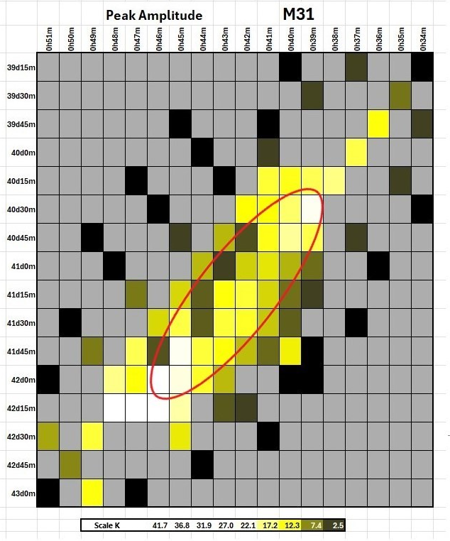

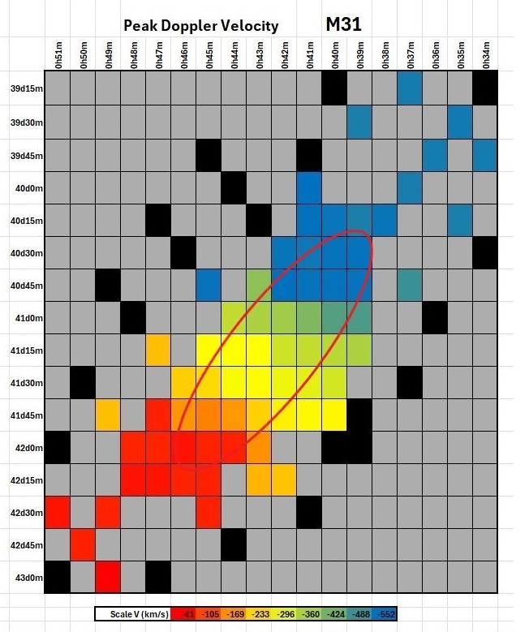

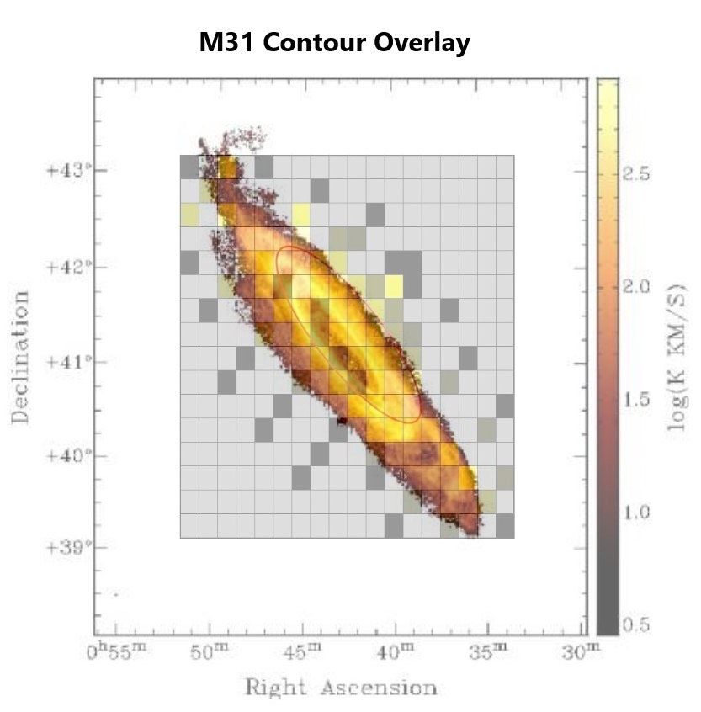

**Results from M33:**

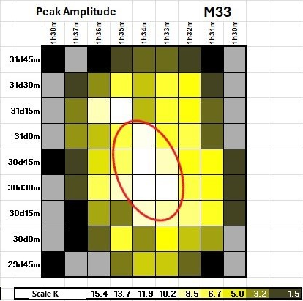

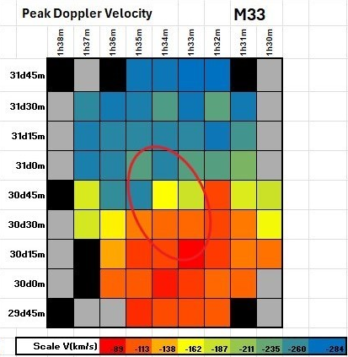

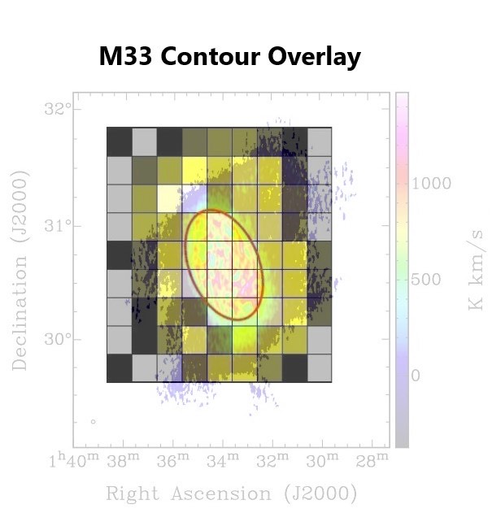

**Results from M101:**

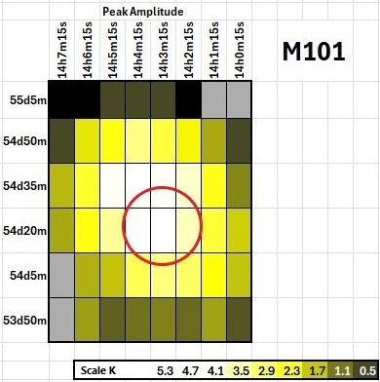

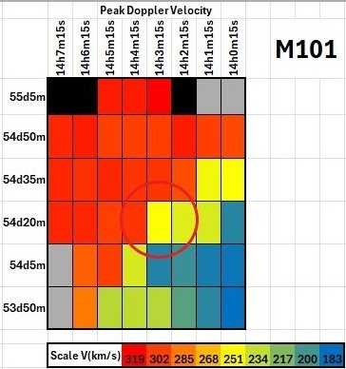

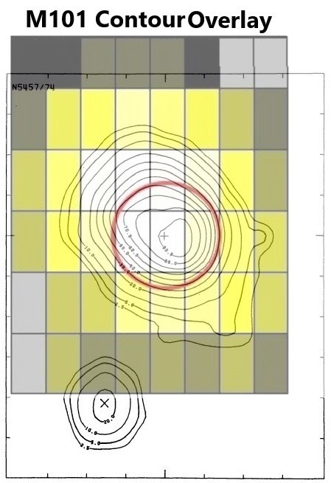

**Results from IC342:**

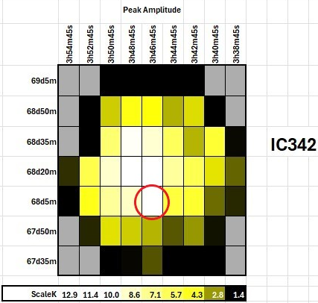

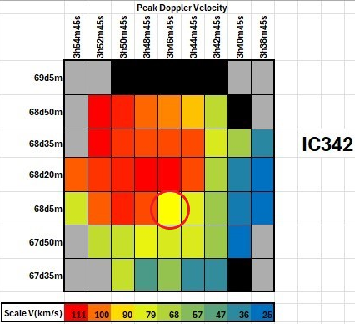

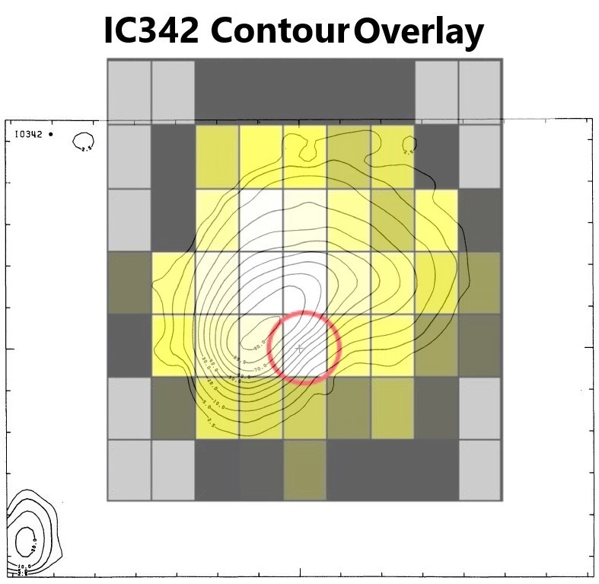

**Results from NGC2403:**

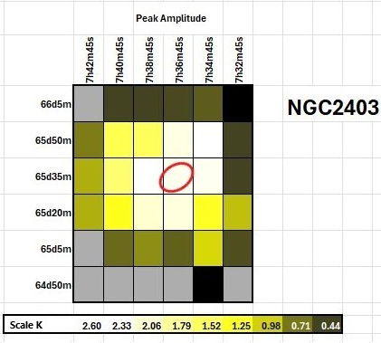

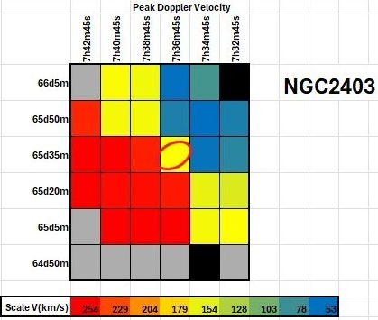

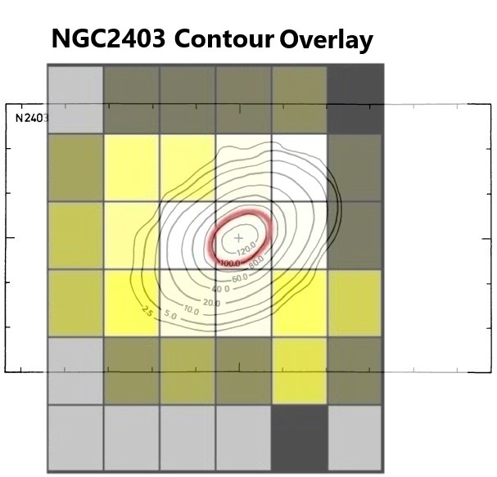

**Results from M81, M82, and NGC3077:**

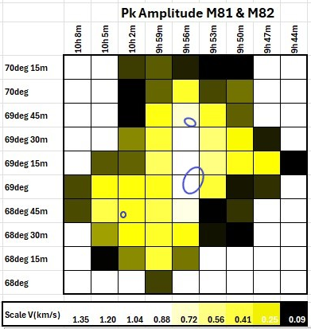

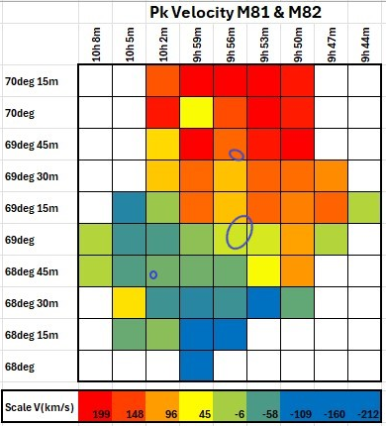

**Where we go from here.**

We plan to conduct a more detailed study of M81 and M82 and their environs, in order to ascertain the extent to which the two galaxies overlap, and their effects upon each other.

**Further information.**

Further information about this project is available on the [www.astronomy.me.uk](http://www.astronomy.me.uk) website or by contacting me using the “contact us” page on that website.

**References.**

A. H. Rots, A Neutral Hydrogen Mapping Survey of Large Galaxies <https://www.researchgate.net/publication/234361514_A_neutral_hydrogen_mapping_survey_of_large_galaxies_I_-_Observations>

Green Bank Observatory 20m, accessed 2025. <https://greenbankobservatory.org/about/telescopes/20m/>

Laurent Chemin, Claude Carignan and Tyler Foster – H I Kinematics and Dynamics of Messier 31 <https://arxiv.org/pdf/0909.3846v1.pdf>

Radio Skynet. <https://www.danreichart.com/radio>

Society of Amateur Radio Astronomers. <https://radio-astronomy.org/>

S. Z. Kam, C. Carignan, L. Chemin, T. Foster, E. Elson, T. H. Jarrett – H I Kinematics and Mass Distribution of Messier 33 <https://arxiv.org/pdf/1706.04248.pdf>

Welcome to Skynet, Skynet 20m: Education and Science Collaboration. <https://www.gb.nrao.edu/20m/>