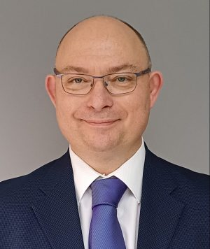

DR ANDREW MARTYN THORNETT, M6THO

Dr Andrew Thornett is a General Medical Practitioner (family doctor) in Birmingham, England, UK, with an eclectic interest and passion for all things astronomy. He is a member of the BAA Radio Astronomy Group and Society of Amateur Radio Astronomers in the USA, and of Rosliston Astronomy Group in Derbyshire, and an associate member of the Astronomical Society of Penang in Malaysia. He has been married to a girl from Penang for the last 26 years, with two children. His website can be viewed at www.astronomy.me.uk

He started his astronomy journey using Dobsonian telescopes for visual observing of the night sky, and for a long-time avoided astrophotography!

He still does some visual and now some astrophotography, but his passion is now for radio astronomy and spectroscopy – which allow him to see the night sky in a different light to that normally available to amateurs.

New types of radio receivers and filters have meant that radio astronomy is possible for people who would have never considered it previously, and for much cheaper prices that was available in the past.

He is very keen to tell the world about this part of the hobby and to encourage others to take it up and observe the night sky with new eyes, opening a world to them previously unavailable.
Linkedin

