Can orthogonal dual monopoles reduce signal strength in a cantenna?
How is cross-polarisation measured?

Extract from SARA Mailing List, 20-21/11/2025.

From: 'b alex pettit jr' via Society of Amateur Radio Astronomers <sara-list@googlegroups.com>
Sent: 21 November 2025 22:38.
BLUE = Feed Beam & Gain Pattern at Feed #1 with a single Feed (Feed #1)
RED = Feed Beam & Gain Pattern at Feed #1 with the addition of Feed#2

CONCLUSION The addition of a second Feed perpendicular to the first (#2) does not influence the performance of the original Feed (#1).

See plots below, from which this conclusion is drawn:

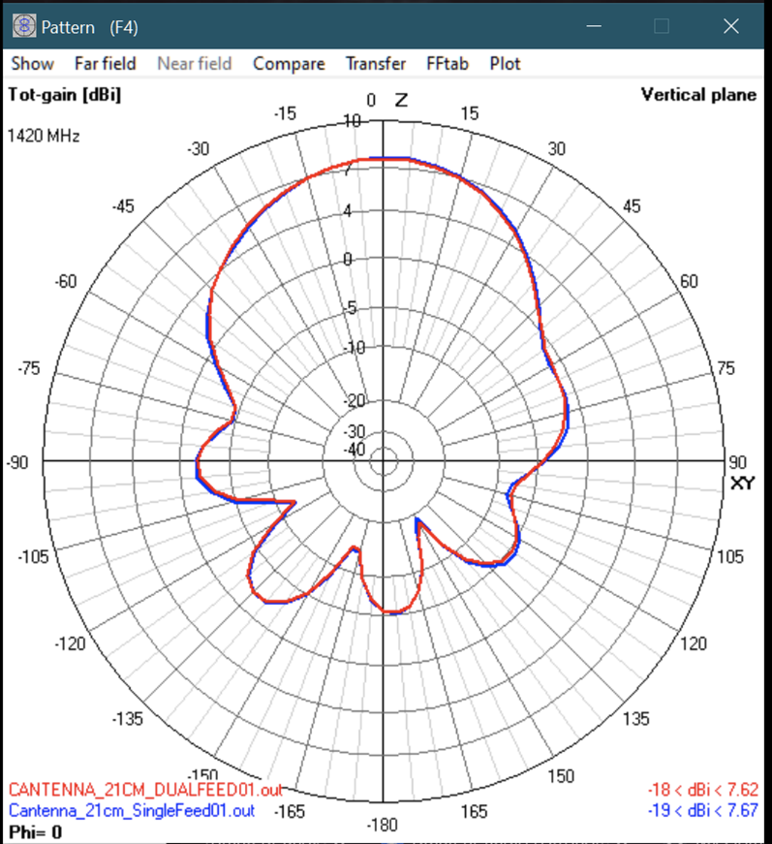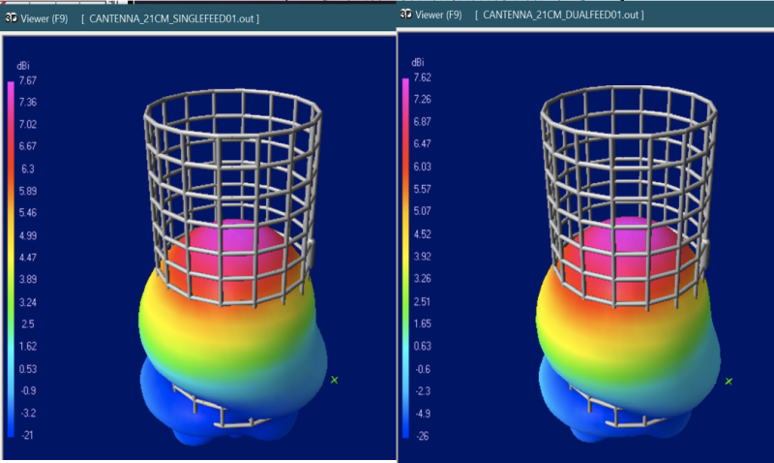

The second feed was modelled as a 1/4WL monopole loaded with 50 ohms Z.

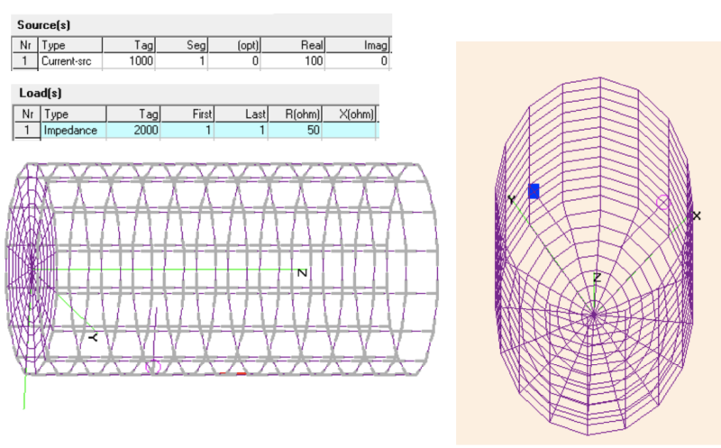

From: ‘Marcus D. Leech’ via Society of Amateur Radio Astronomers <sara-list@googlegroups.com>
Sent: 21 November 2025 22:31.
If the probes are perfectly at 90 degrees, then the coupling between them should be quite minimal, but experience would suggest (and I have not looked at the equations) that there is an unpleasant square-law that comes into play as they deviate from 90deg from each other.

From: 'fasleitung3' via Society of Amateur Radio Astronomers <sara-list@googlegroups.com>
Sent: 21 November 2025 15:45.
You will need a test signal generator and a highly polarized antenna. We use a commercial log-per antenna for that purpose.
You measure the power with the polarization aligned to one port and then turn the test antenna or the feed horn by 90°. The drop in signal is the cross-polarisation.
Wolfgang

From: 'Andrew Thornett' via Society of Amateur Radio Astronomers <sara-list@googlegroups.com>
Sent: 21 November 2025 09:32.
Is there a simple way I can measure cross polar isolation on my set-up?
Andy

From: 'fasleitung3' via Society of Amateur Radio Astronomers <sara-list@googlegroups.com>
Sent: 21 November 2025 08:33
We are using a cantenna with two probes at 90° and the same distance as part of our sun-polarimeter, very much like Marcus has described. We took care that the two probes are exactly at 90° and verified isolation from each other by measuring the cross polar isolation which was > 15 dB.
In our case we keep the two signal chains separate as we process the data later digitally to calculate the 4 Stokes parameters. My understanding is that if the cross polar isolation is sufficiently large the two probes will not influence each other.
Wolfgang

From: 'Marcus D. Leech' via Society of Amateur Radio Astronomers <sara-list@googlegroups.com>
Sent: 20 November 2025 19:50.

In my humble opinion it is very likely going to cause trouble to put another conductor in your feed can. Maxwell's equations always win!! Mother Nature knows best. I am not sure there is anything "mother nature-like" about a circular waveguide microwave feed horn :)
It is instructive to look at Ku-band LNBFs with the "lid" off. They have a pair of probes, orthogonal, and about 90deg separated in the circular waveguide. These are then combined in-phase to produce circular polarization of the correct chirality. Similarly for C-band LNBFs. Plenty of other structures out there that provide for ortho-linear polarizations as well. Like crossed Yagi antennas, turnstile antennas, ortho-fed patch antennas (we have one of those). There are also septum feeds that have a stepped septum down the middle and two probes on the same plane.
Now, do the two probes interact with each other? Yes.
It will be interesting to see the NEC simulation. I have used an ortho-feed approach in can feeds in the past with no noticeable issues, although I have not tried to form either CP from those probes, choosing instead to treat them, as Andrew has, as separate receive chains.
From: Andrew Thornett <andrew.thornett@googlemail.com>
Sent: 20 November 2025 23:10
I recently I tried using two probes same length, same distance from bottom cantenna – it seems to me that this has adversely affected the signal power level detected on both probes – is that a sensible suggestion?

Andy

