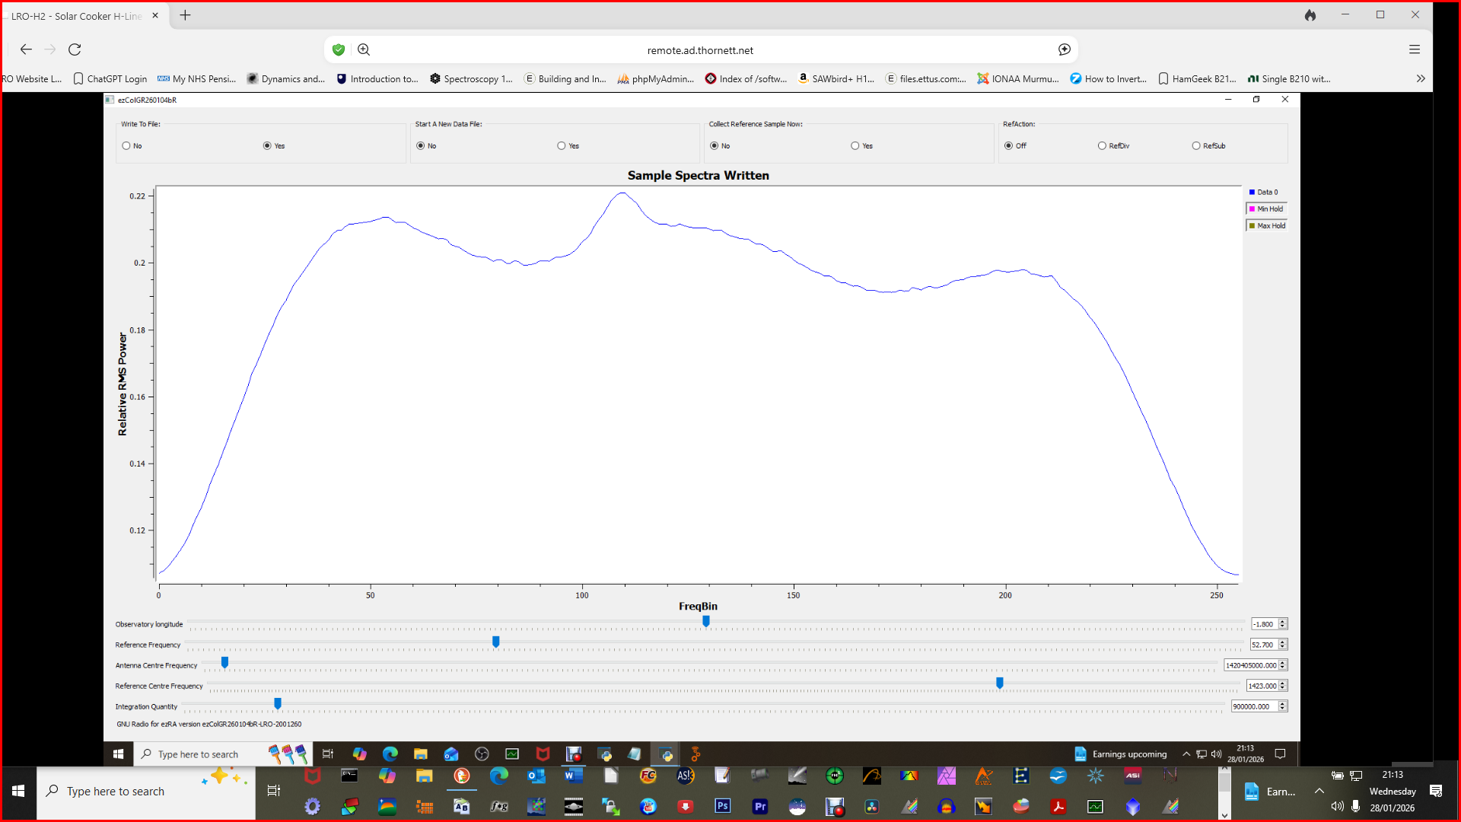
Antenna sample above from Reference display option set to “Off” on GR version ezCol (this displays raw antenna and reference samples – other options are to subtract reference from antenna on display or to divide antenna by reference on display). None of these options affect the data stored in data file.
Reference sample below same settings:
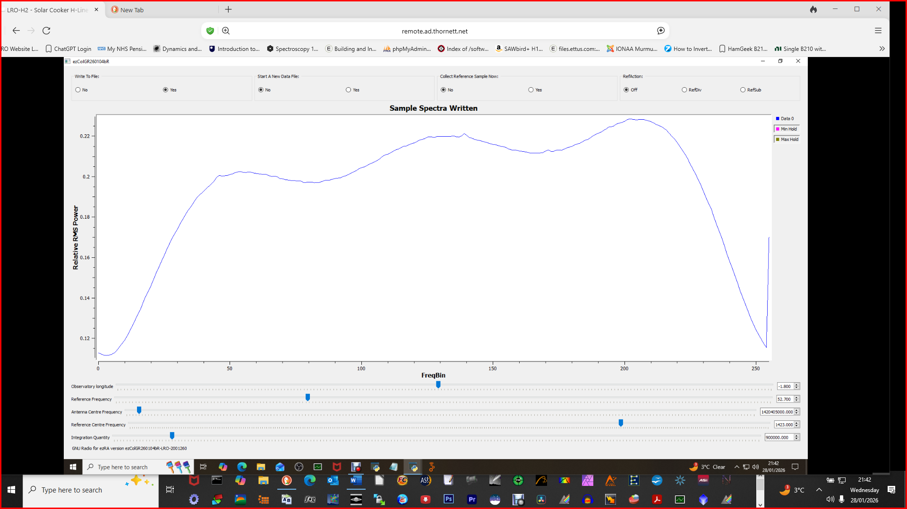
Data collection using ezColGR on Ptarmigan Triffid Array:
