Updated 24/10/2024:

- Load data .txt files created by ezCol into “data” directory (LRO-data). Note they will be combined in final file.
- In LRO directory (not data), type CMD in address line.
- Run following:
py ../ezRA/ezCon241021a.py data -ezConPlotRangeL 87 87 -ezCon087Csv 1
py ../ezRA/ezCon.py data -ezConPlotRangeL 87 87 -ezCon087Csv 1
py ../ezRA/ezCon241021a.py data -ezConAntXTFreqBinsFracL 0 1 -ezConUseVlsr 0 -ezConAntXTVTFreqBinsFracL 0 1 -ezConPlotRangeL 87 87 -ezCon087Csv 1
py ..\ezRA\ezSky241021a.py . -ezSkyInput 14 -ezSkyPlotRangeL 400 520 -ezSky400Csv 1 -ezSky500Csv 1 -ezSky520Csv 1
py ..\ezRA\ezSky241021a.py . -ezSkyInput 18 -ezSkyPlotRangeL 400 520 -ezSky400Csv 1 -ezSky500Csv 1 -ezSky520Csv 1
py ..\ezRA\ezGLon241118a.py . -ezGlonGalCrossingGLonNear 2 -ezGLonPlotRangeL 580 580 -ezGLon580CsvFrac 0.15 -ezGLonGalCrossingGLonCenter 70

- A single combined data file will be created compatible with Rinearn3d software called ezCon087antRBTVT.csv
- From CMD started in LRO directory, type:
D:\ezRA_Programs+Data\ezRABase\rinearn3d\rinearn3D.bat ezCon087antRBTVT.csv
An alternative to above is to run rinearn3D.bat directly by clicking on link (in rinearn3D directory) and then open file and select the CSV file above.

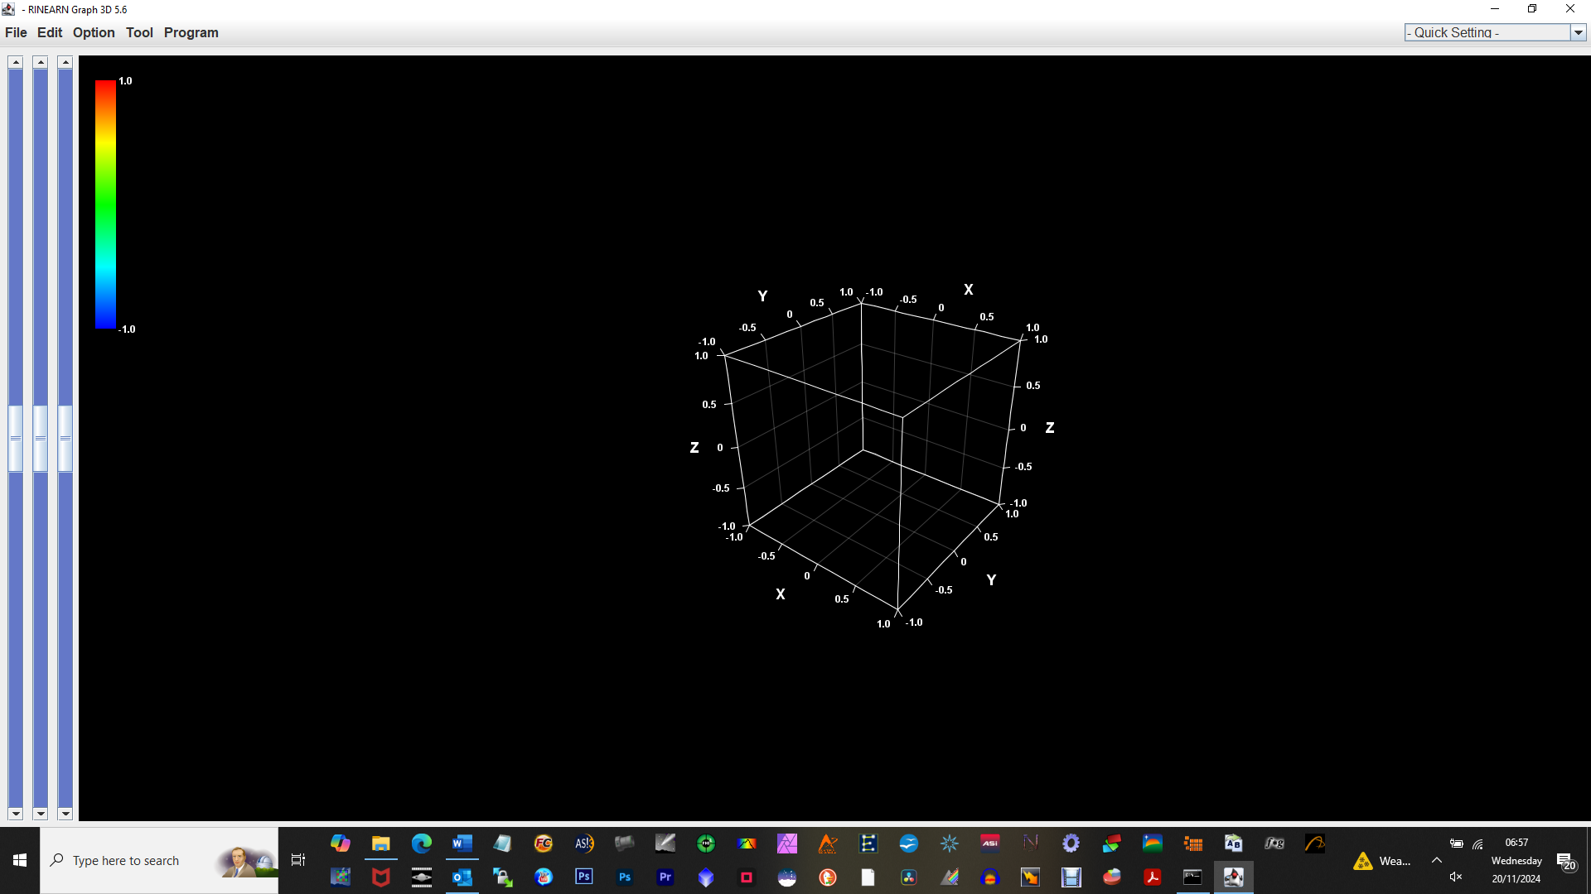
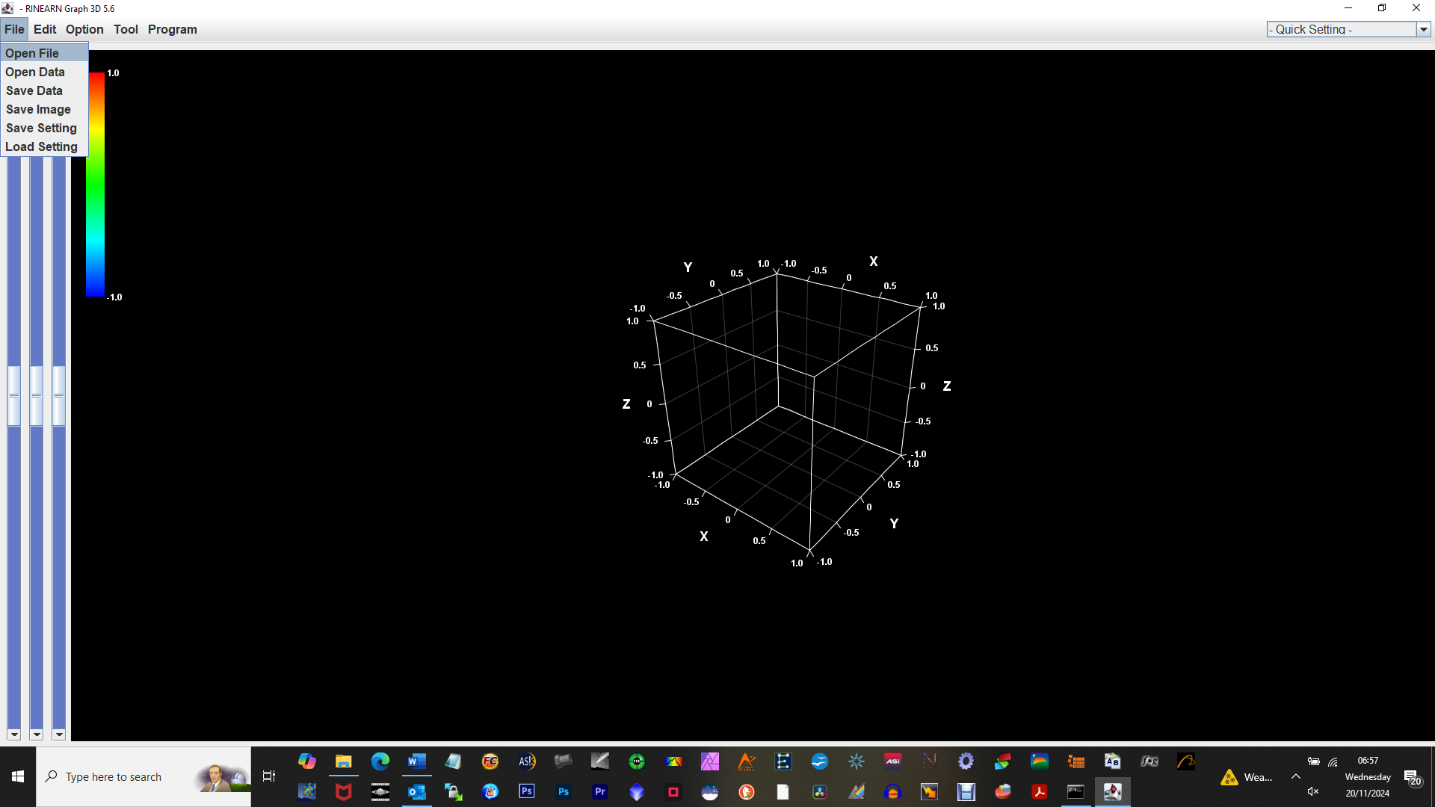
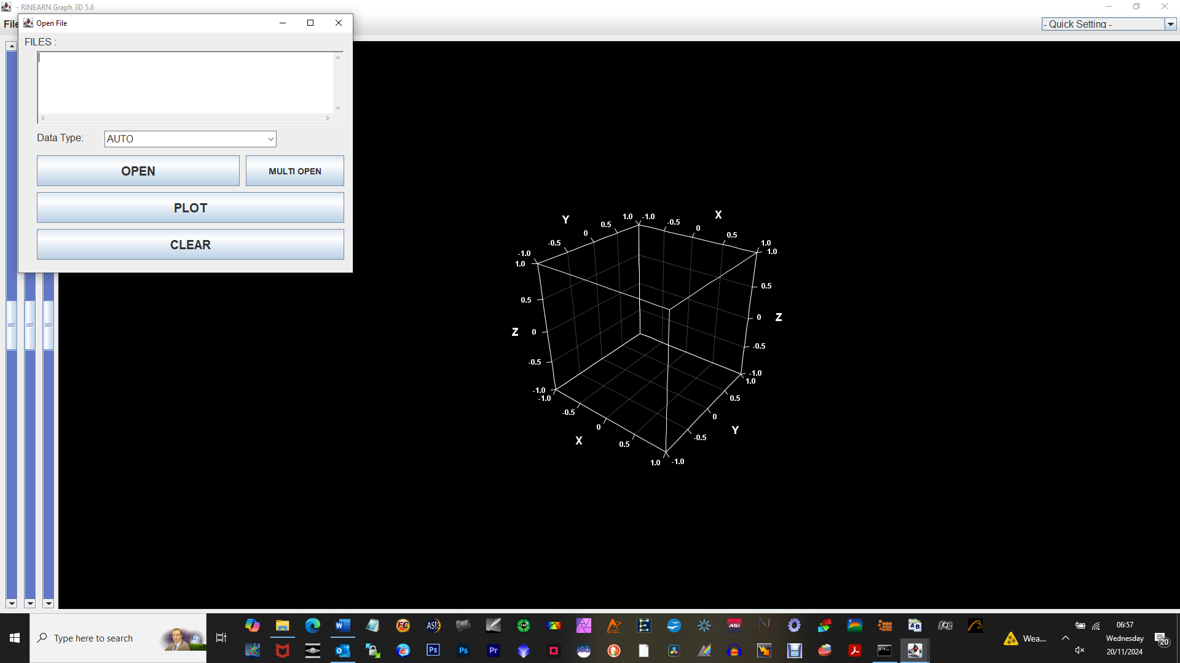
Click <Open>
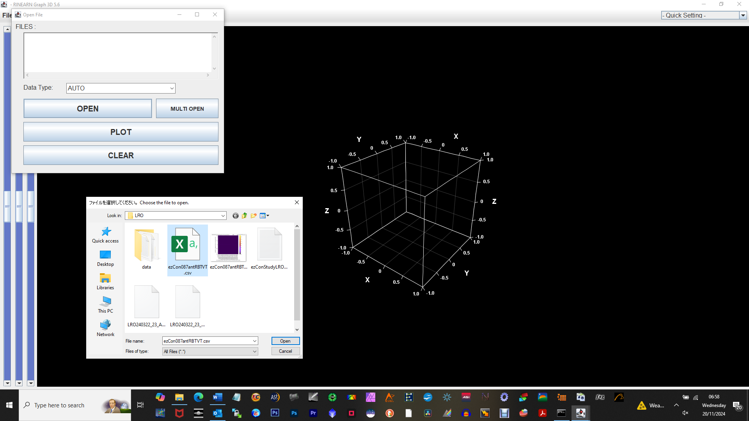
Select CSV file in LRO sub-folder
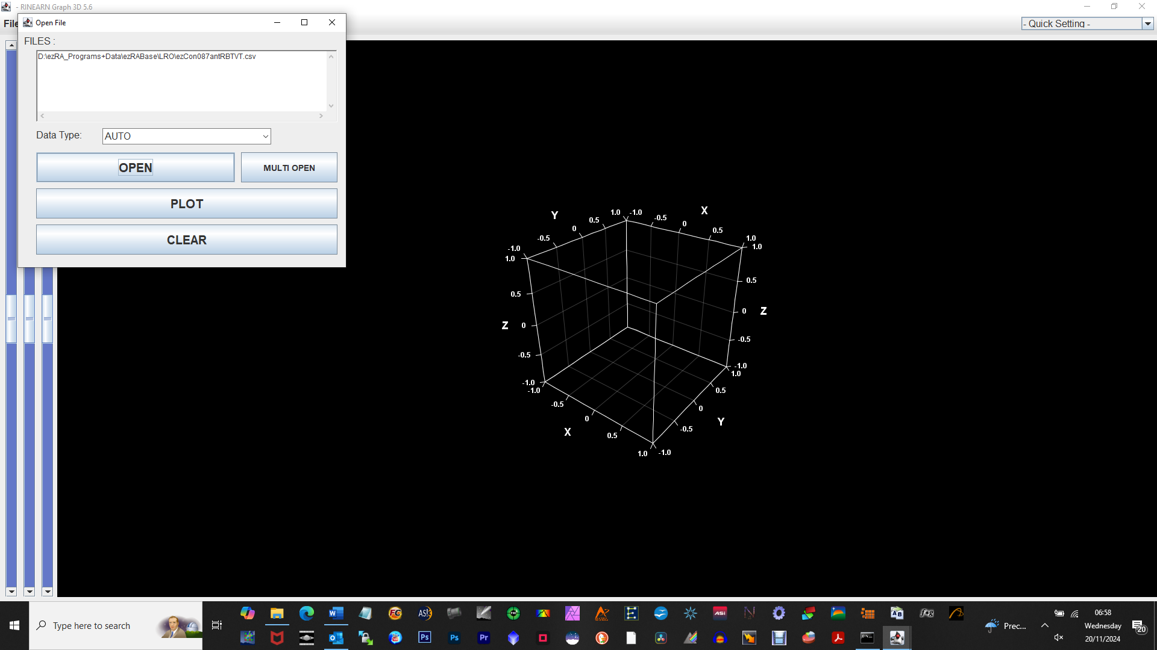
Press <Plot>

