SID Station using Spectrum Lab

These instructions are for v2.96 b2 – I assume other versions will work

Antenna
Is about 22 inches square and I used 100m meters of copper wire
Emtel 0.645 mm (22 AWG) - 500 gr (1 LB) - 155 meters Magnet Wire - Enameled Copper Wire for Electrical Motor Transformer Magnetic Coil 220°C (428°F) Thermal Class - Double Insulated Winding Wire - https://www.amazon.co.uk/dp/B08QL31YVT?ref_=ppx_hzsearch_conn_dt_b_fed_asin_title_1&th=1
There may well be cheaper alternatives
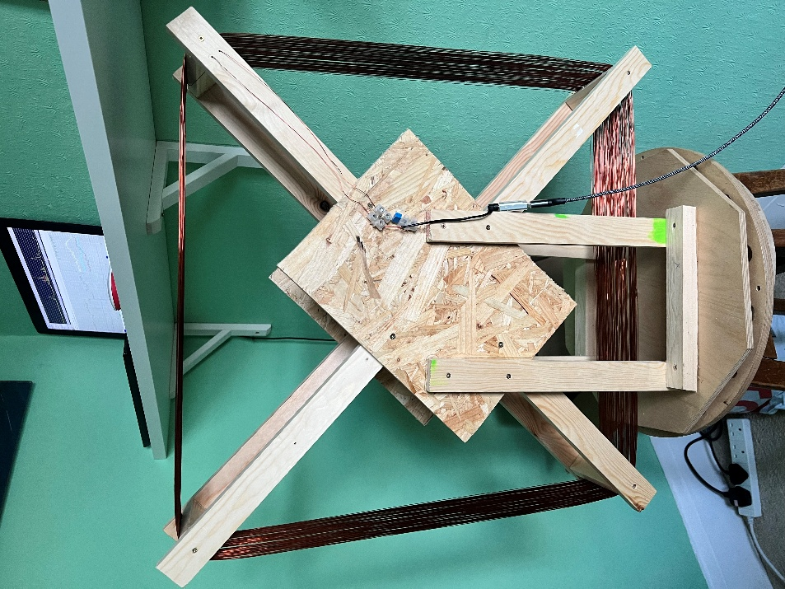

External USB Sound Card
USB A External Sound Card, Cubilux USB Headphone Adapter with 96 KHz/24-bit DAC, USB Audio & Microphone Dongle with 3.5mm Jack Compatible with Monitoring Playback, Windows MacBook Laptop PS5 - https://www.amazon.co.uk/dp/B0B49GP2ZN?ref_=ppx_hzsearch_conn_dt_b_fed_asin_title_4&th=1

Connection made like this

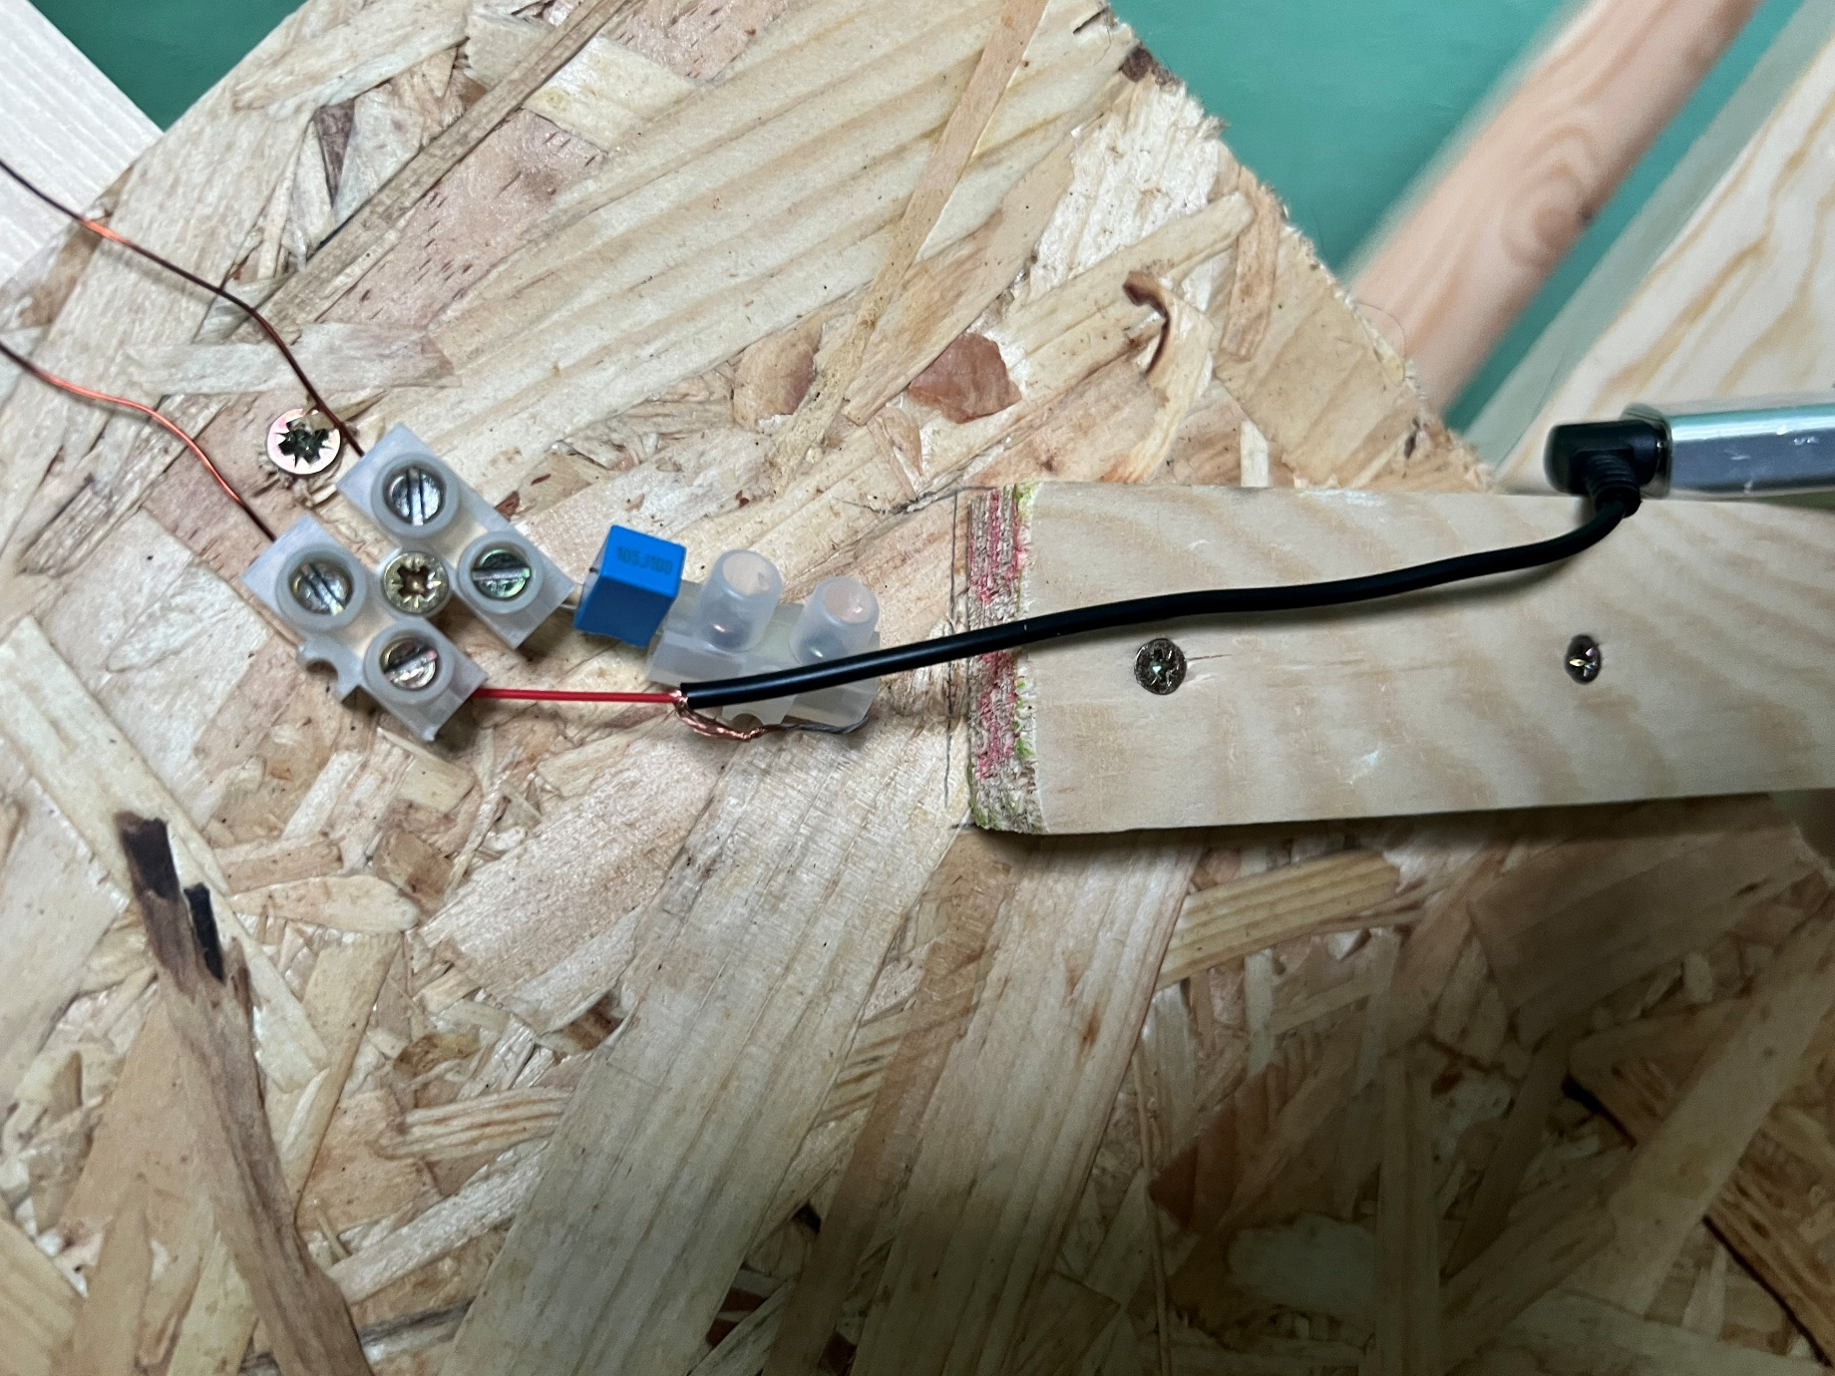
“Some of these external sound cards are DC coupled to allow for powered microphones.
Adding a loop shorts the input to ground and stops the card from working.
AC couple the loop with something large like a 1 to 10 uF non polarized capacitor, eg a polyester capacitor?”
And finally, I have a
USB Extension Cable 5M, Long USB2.0 A Male to A Female Cable USB Extender Lead High Speed Data Transfer Compatible for Printer, Scanner, Camera, Keyboard, Card Reader, Hard Drive, Disk
https://www.amazon.co.uk/dp/B0DS2DNQ2J?ref_=ppx_hzsearch_conn_dt_b_fed_asin_title_3&th=1

Add script workingconfig 6 feb 2026.usr file in the spectrum lab \ configuration folder or a folder of your choice

When you start SL load settings from and select the file you saved above

It should now just work, some screen shots below may help

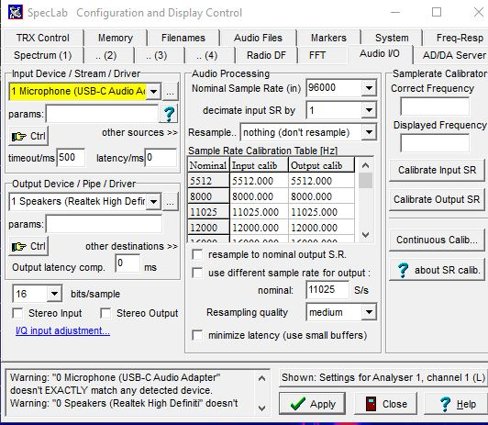
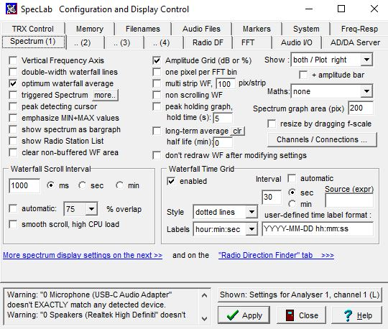

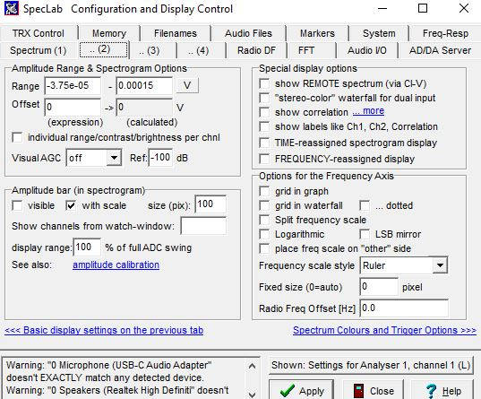

In SL if you don’t see the Plot Window go to View \ Windows and select Plot Window

There are lots of options here
Channels & Colours I useful as is Horizontal
Watch list is key if you add or remove frequencies you need to update the conditional actions so the log file gets written

