21/7/2026.
1.2m dish, Norsat 9000 LDF LNB, Nooelec SMARTee XTR SDR.
Pointed at sky:
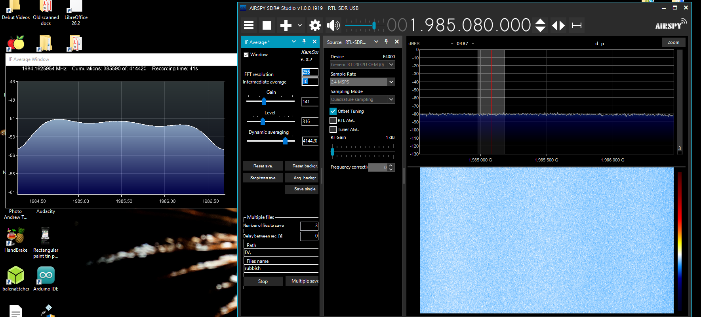

Pointed at ground:
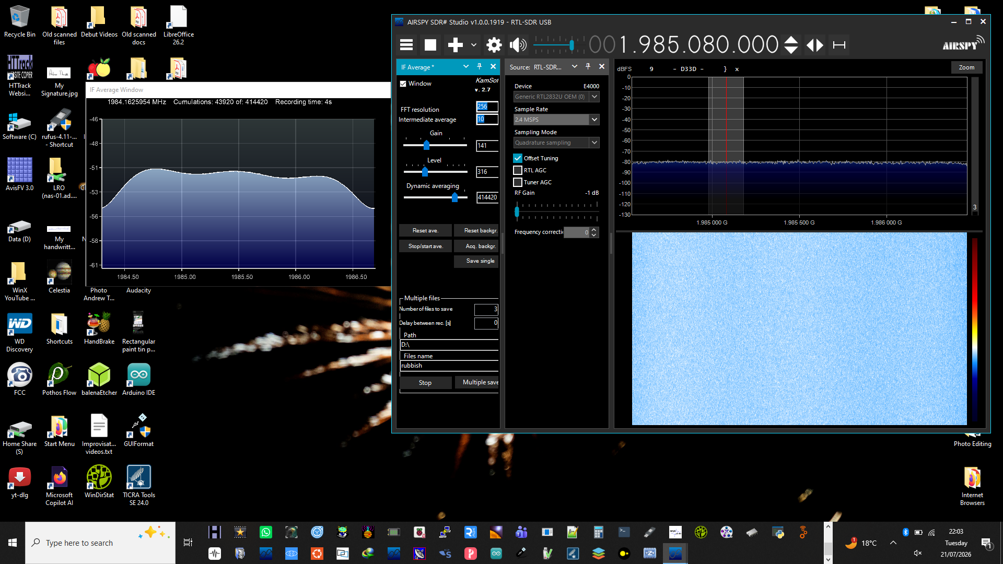
22/7/2026:
Pointed at sky:
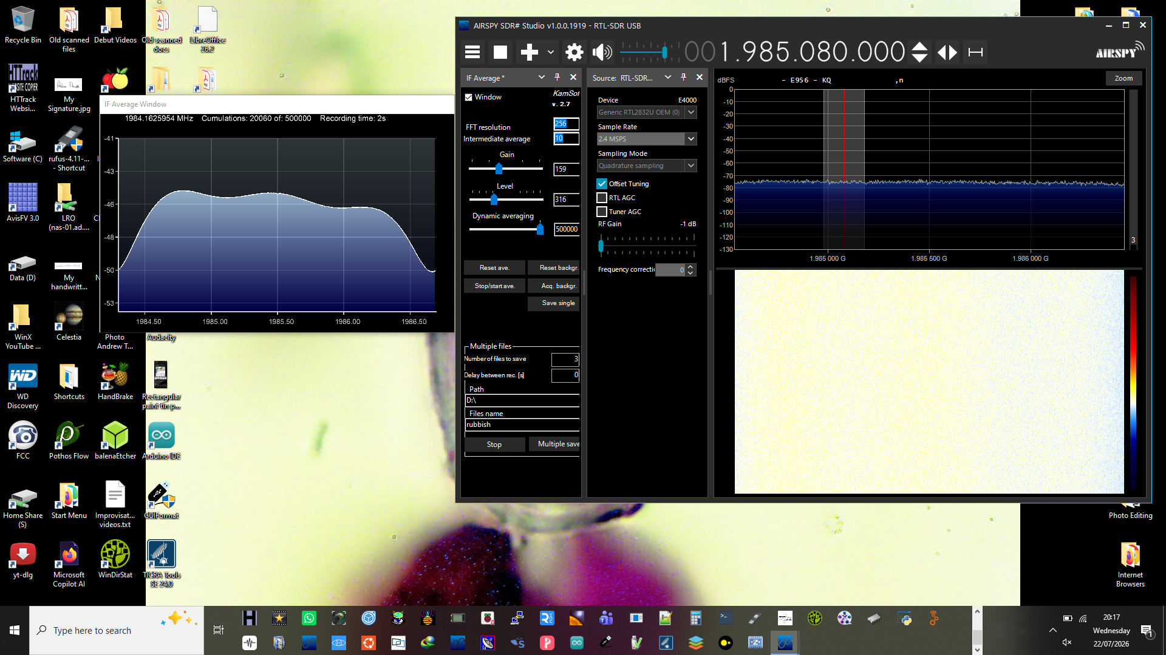
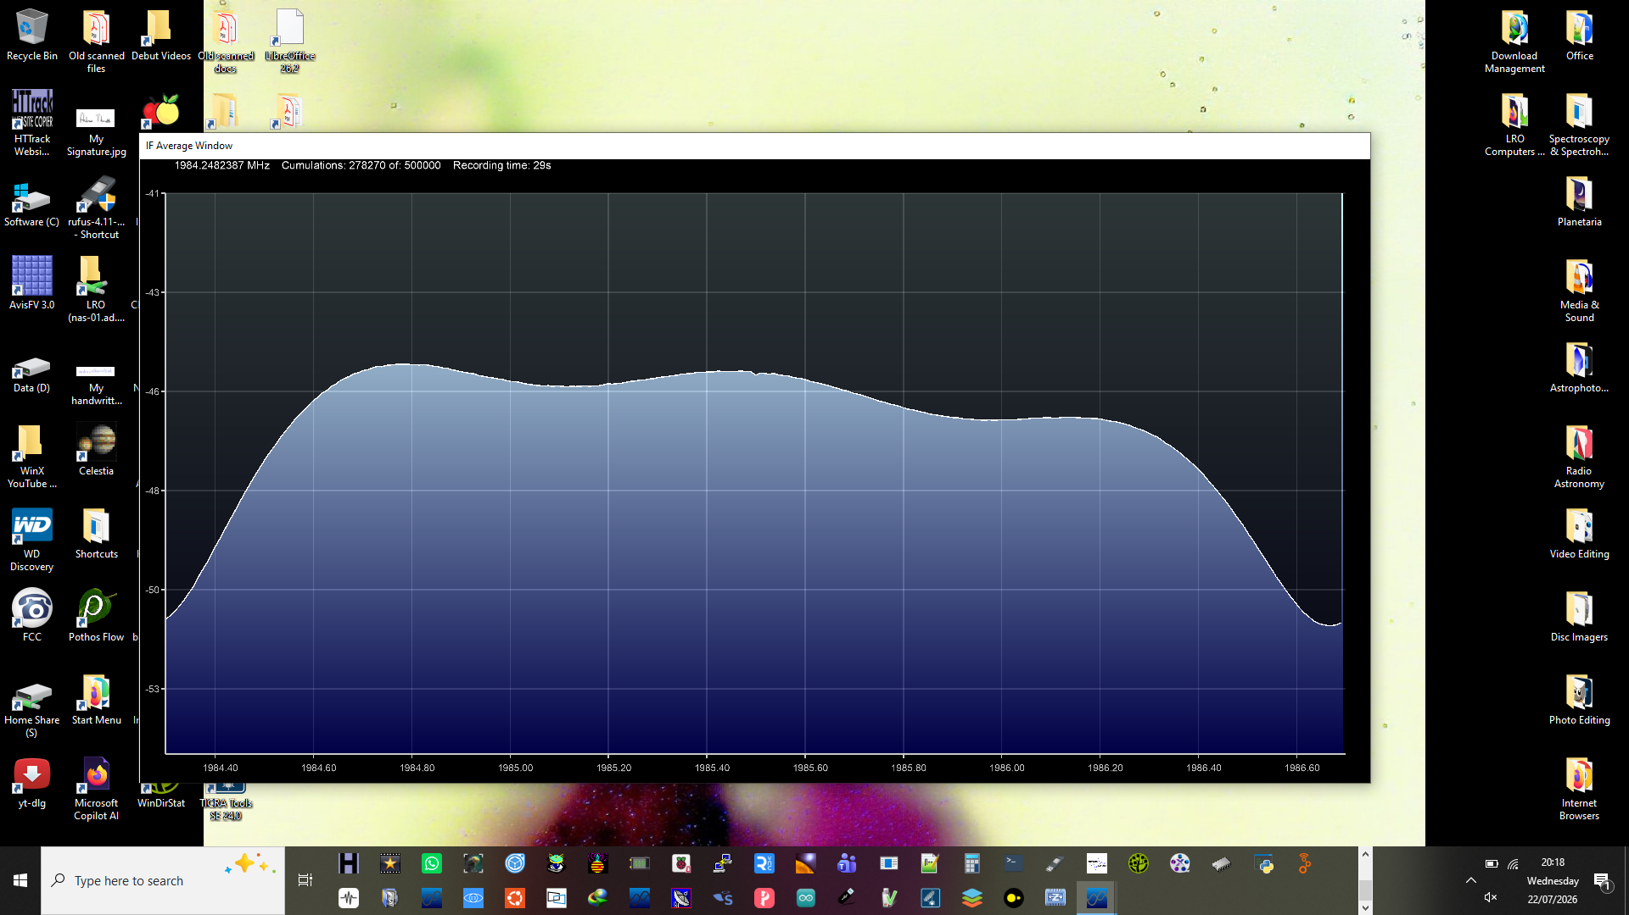
Pointing at house:
